**Linux exercise**

1. Create a hard link named /home/localuser/backups/source1.txt for the existing file, /home/localuser/files/source.txt. (Create existing file and add dummy content)

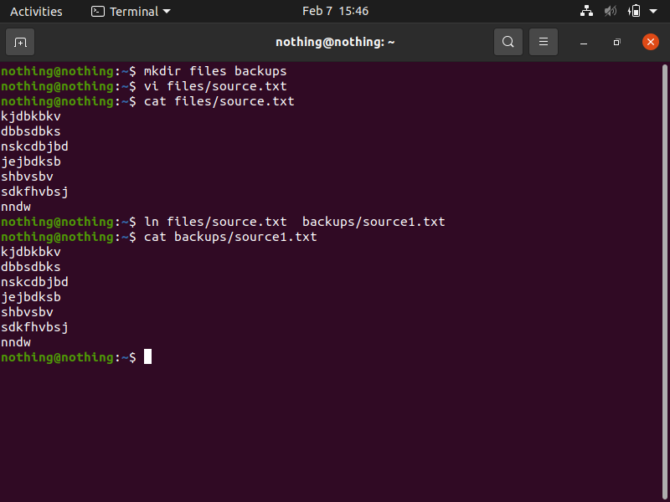

2)Create a soft link named /home/student/tempdir that points to the /tmp directory.

